# How to deal with Unassigned Balances

It is possible to see an ‘Unassigned Balances’ issue when reviewing the Monthly Reports -> Financial Statements; similar to the following under the ‘balances’ tab:

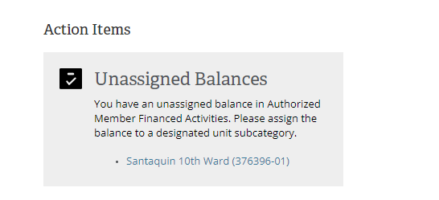

If you see this, it just means you need to execute some transfers.

Just above this dialog box, expand the ‘Local’ section by clicking the arrow; and you’ll see something like this. Notice the values on the right hand side; they should all be zero before the report is approved.

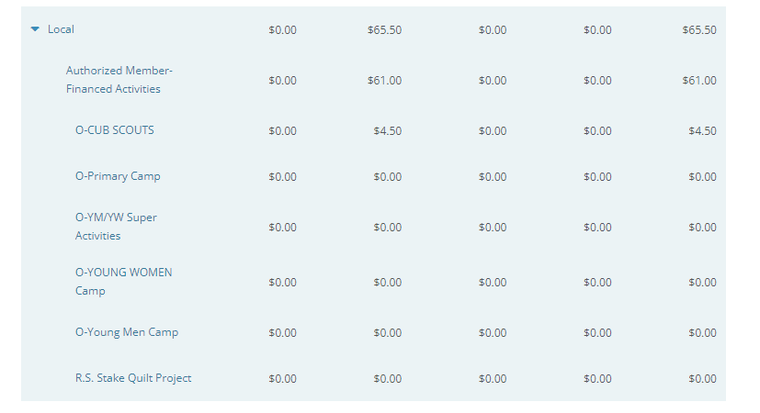

There’s a drop down for ‘Local’ which should all resolve to a 0 balance on the right hand side, such as this one:

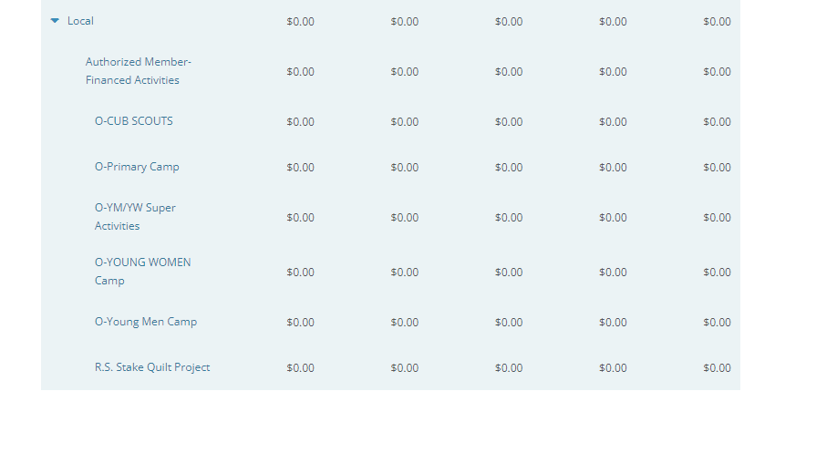

Note regarding this resolution:

* First: you should know that as you bring the balances above to zero, The Unassigned balances warning WILL NOT disappear. Second, the ‘local’ section above will NOT be updated. To verify things are resolved, use the Overview -> Income and Expense Summary - > expand ‘Local’, and confirm all the balances on the right hand side are 0.

8/27/2022 12:30:45 PM - Update: These categories are reportedly going a way; these instructions are likely outdated now; though there may be similar resolution to related issues.